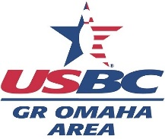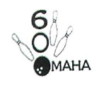 **OMAHA 600 CLUB**

**TOURNAMENT FOR WOMEN**

**4TH annual “vi brannen memorial”**

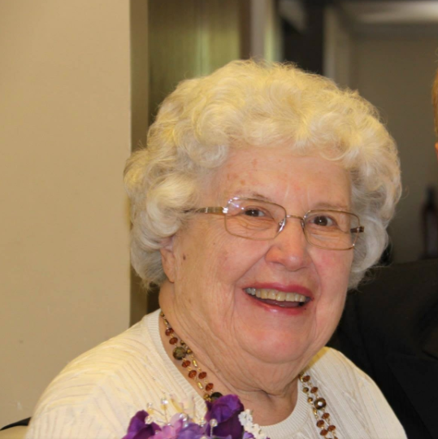

**February 23, 2025 western bowl**

**Squad times: 10 am & 1 pm**

**Open to all adult, female**

**usbc certified bowlers**

**doubles only $25 per person**

**contact BOWLING ASSOCIATION to reserve**

**402-551-4007 or barb@gobowlomaha.org**

**or mail to: GOABA, 151 N 72 St., Ste 3A, Omaha 68114**

**Walk in entries allowed as space permits**

4TH Annual VI BRANNEN MEMORIAL DOUBLES TOURNAMENT- RULES

1. ELIGIBILITY: This USBC certified tournament is open to all adult, female bowlers who are current or associate USBC members.

2. EVENT: Doubles: Two bowlers, three games each bowled plus handicap. Paired bowlers’ scores combined.

3. DIVISIONS: A: Combined averages of 350 and above B. Combined averages of 349 and below.

4. ENTERING AVERAGE: Bowlers will enter using their highest, certified average, 21 game minimum, in this order: 2023-2024 winter or summer; current certified league average of 21 games or more. If neither of these, bowlers will enter at 235.

The GOABA USBC 2023-2024 Yearbook, bowl.com and current league standing sheet will be used to verify. Bowlers are required to declare correct average if their published average is not accurate.

5. HANDICAP: Doubles handicap is 100% of the difference of combined, entering averages from 470, per game.

6. ENTRY FEE: $25 per person- $13 per person to prize fund, $12 per person for lineage. MULTIPLE ENTRY allowed with different partner.

7. USBC Rule 319a3 regarding responsibility for average verification applies. USBC Rule 319e, Average Adjustment, USBC Rule 319d, Reporting Prior Prize Winnings and USBC Rule 319a2, Re-rate, are waived.

8. PRIZES: Payout ratio in each division will be at least 1 in 5 entries. 100% prize money is returned in the division in which it was collected.

Barb Melonis, Association Manager Yvonne Goodman, Tournament Director

